**HANOI-APTECH INTERNATIONAL PROGRAM TRAINING SCHOOL**

**PROJECT REPORT (ORGANIC FARM)**

Project report made by four students:

1. Nguyen Ba Tuan Anh
2. Bui Duc Thanh
3. Nguyen Tuan Kiet
4. Nguyen Minh Quang

Table of Contents

1. Introduction 1

2. Statement of the Problem 2

3. User Requirements 2

4. Objectives 3

5. Scope of the Project 3

6. Screen Show 3

7. User guide 3

## Introduction

Scientists and biologists define spices as foods, herbs (typically containing essential oils), or chemical compounds added to food that have the potential to produce the most gratifying stimulus. determines a person's ability to taste, smell, and see food. In addition to improving food's flavor and making it simpler to digest, spices can also be processed for various food kinds in accordance with the yin and yang development and mutuality principles. unique items. There are many different kinds of spices, including fish sauce, salt (to create a salty taste), chili, pepper, and herbs (basil, laksa leaves, onions, garlic, etc.—served with or added to food during processing). The use of the right spices for the dish always reflects the creativity and sophistication of the chef as a culinary artist. In addition to being crucial elements in wonderful, fully flavorful recipes, spices can impart the cultural traits of a nation or a people. With the help of Organic Farm you can freely choose the seasoning you are looking for, the special special spices for your dish along with the clearly listed prices above make the selection easy and more convienient than ever.

## Statement of the Problem

The problem is happening in the home system:

* *Prime Cost:*

To open a physical store, you have to prepare a small amount of capital, the space rent alone costs several tens of millions, even hundreds of millions if it is a convenient location such as the street or the central area. Then you have to repair and decorate the store to attract customers, buy equipment, if it is a large scale, you still need a warehouse to store it. Thus, the average store construction cost alone cost at least nearly one hundred million.

* *Management Ability:*

Managing a physical store is definitely a lot more complicated than an online store, in addition to controlling product information, buying - selling, exporting - importing activities, you also have to manage employees.

## User Requirements

The user requirements are considered as follows:

1. You can search for spices by category, making it easier to find.
2. You can directly know the price compared to the market to make buying according to their finances more convenient.
3. Moreover, if you have any question about the selection, you can contact the hotline, which is availabel 24/7.

## Objectives

The goal of the project is to develop a website to manage information about spices. The main objectives of this website development can be defined as follows:

1. Building a system that provides function to support suppliers to view and manage products conveniently.
2. To store all kinds of raw materials, remaining products and medium products in the database system.
3. To support to look up materials convient for both buyers and sellers.
4. To provide a function of sending an e-mail to suppliers about their user about product status as well as quality feedback.

## Scope of the Project

* Registration

This function allows the carrier and administrator to regrister as a user to interact with the system. The system requires the user to login before editing any information.

* Data is input by the Administrators

Material information can be sent by calling or e-mail. The administrator is reponsible for entering the received data into system.

* Product management

The system uses first-in, first-out warehosue management, products that are first to be supplied to customers.

When the product runs out, the administrator is reponsible for notifying the distributor and updating the system.

* Request more products

Customers can request additonal products by e-mail and by calling the distributor.

## Screen Show

Home Page

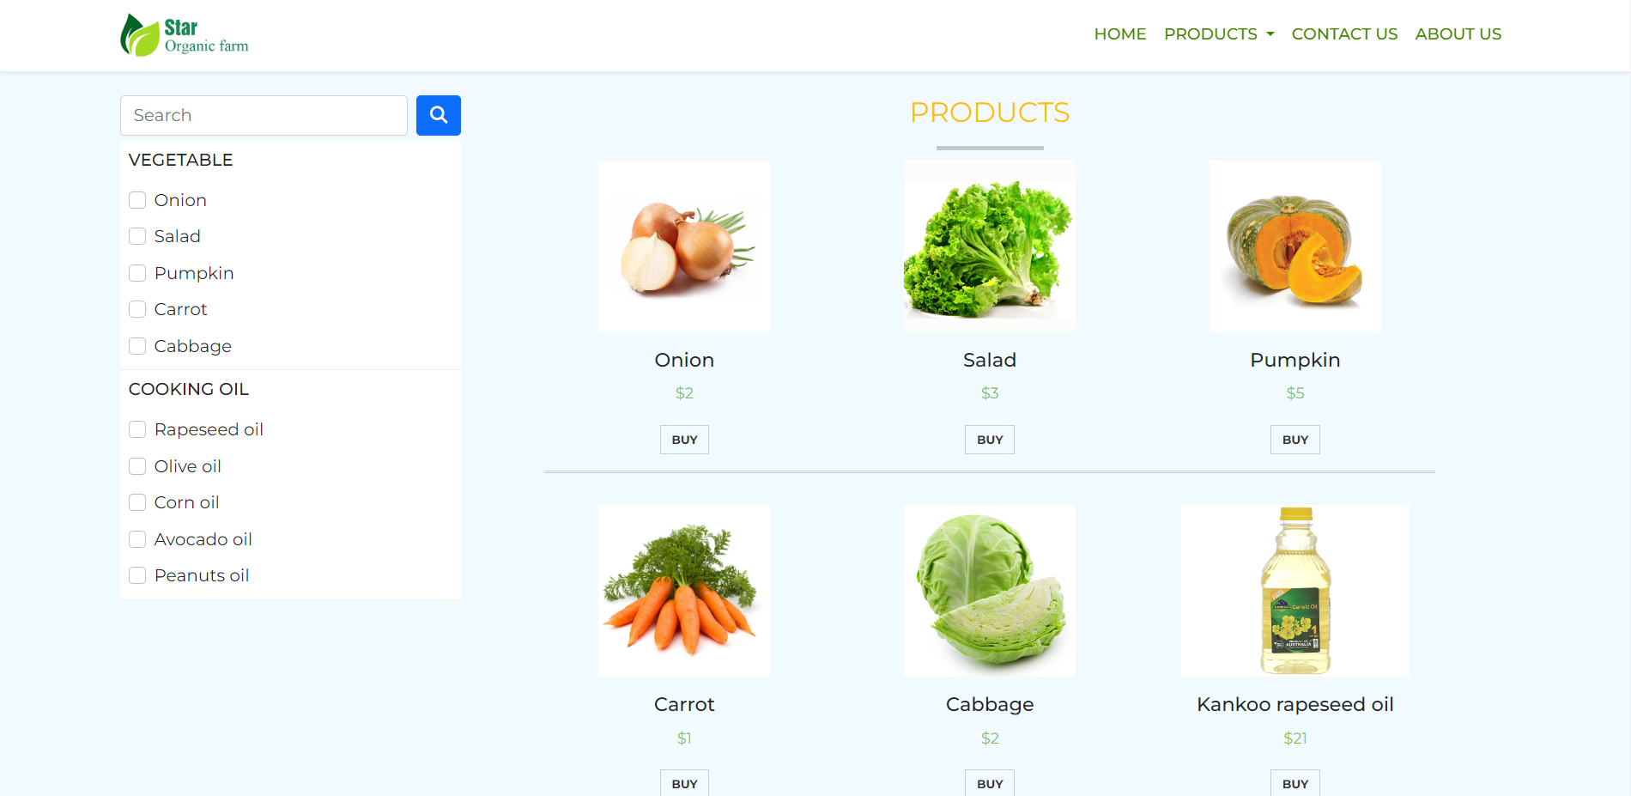

Products Page

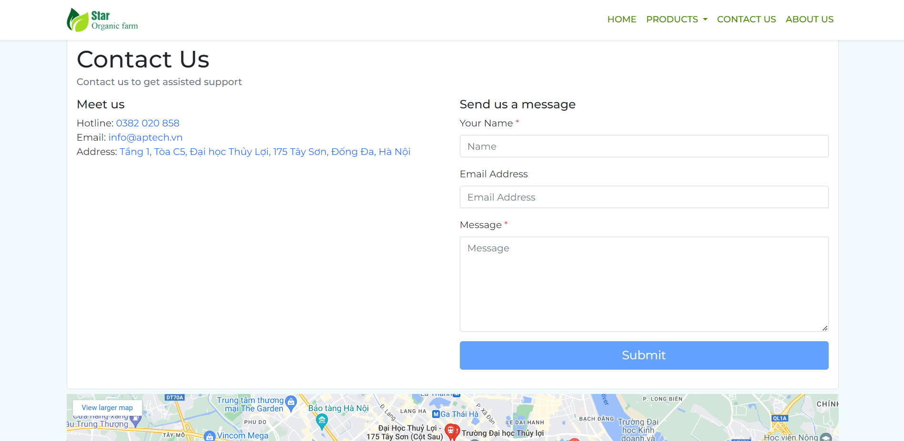

Contact

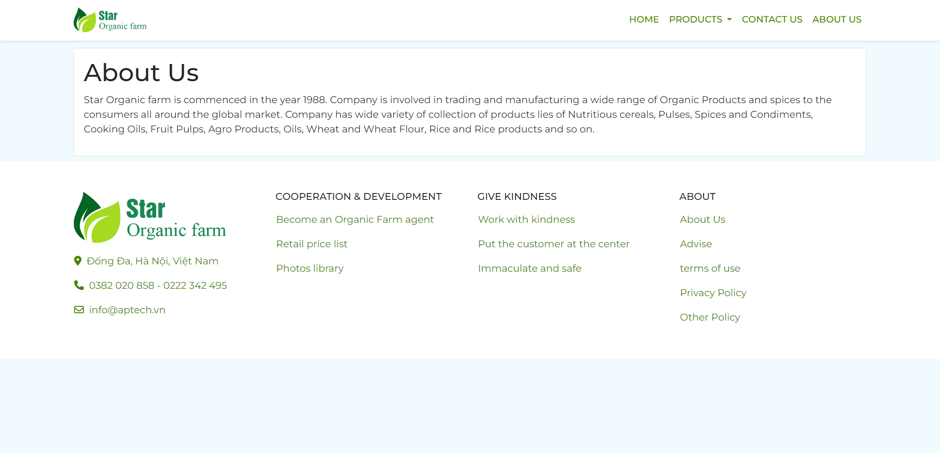

About us

## User guide

Basically, the website can help you easily find the spices you want. The home section is designed to show you some of the popular consumer products that you might be looking for.

To access more products, you can go to the product section on the menu bar next to the day it will help you find the ingredients according to the category you want. Graphical user interface, application

And if you have more specific questions about any product please visit contact us there will have full information as well as a complete address for you.